Lab 8 – Docker, containers and images
Jad Moharam – ID 202400899 – AUB username jmm47
Software Tools Lab
GitHub repository: https://github.com/JadMoh123/Lab8-Jad-Moharam

Build and run the first container
A "Hello, World!" Flask app (folder hello flask) was containerised with the Dockerfile from the handout, built and run:
docker image build -t flask_docker .
docker run -p 5000:5000 -d --name flask_docker_app flask_docker
Opening http://localhost:5000 returns "Hello, World!".

Activity 1

docker ps -a
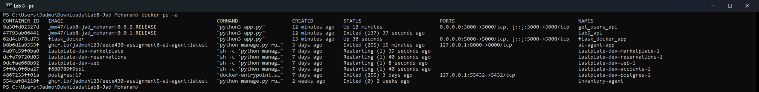
docker ps -a
docker ps -a lists all the containers on the machine, both running and stopped, with their container ID, image, start command, creation time, status, port mappings and name. Without -a only running containers are shown. Here flask_docker_app is Up and mapped to port 5000, and get_users_api is Up on port 3000.

docker logs <container>
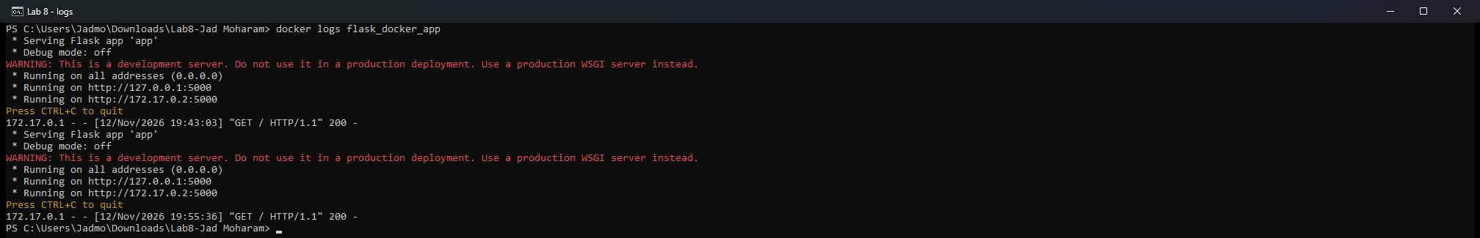
docker logs flask_docker_app
docker logs prints everything the container wrote to its standard output and standard error: here Flask's start-up messages and one line for every HTTP request it served (GET / returned 200). The container was started twice, so the log shows both runs.

docker stop <container>
docker stop flask_docker_app, then docker ps -a for that container
docker stop stops a running container: Docker sends the main process SIGTERM and, if it has not exited after 10 seconds, SIGKILL. The container is not deleted – docker ps -a now shows it as Exited, and it can be started again with docker start. docker stop and docker logs take a container name or ID, which is why the container was given the name flask_docker_app.

Activity 2
Docker image names must be lowercase and a tag cannot contain ":", so lab8-Jad_Moharam with tag 0.0.1:RELEASE is written jmm47/lab8-jad_moharam:0.0.1.RELEASE, the same format as in the handout's screenshot.
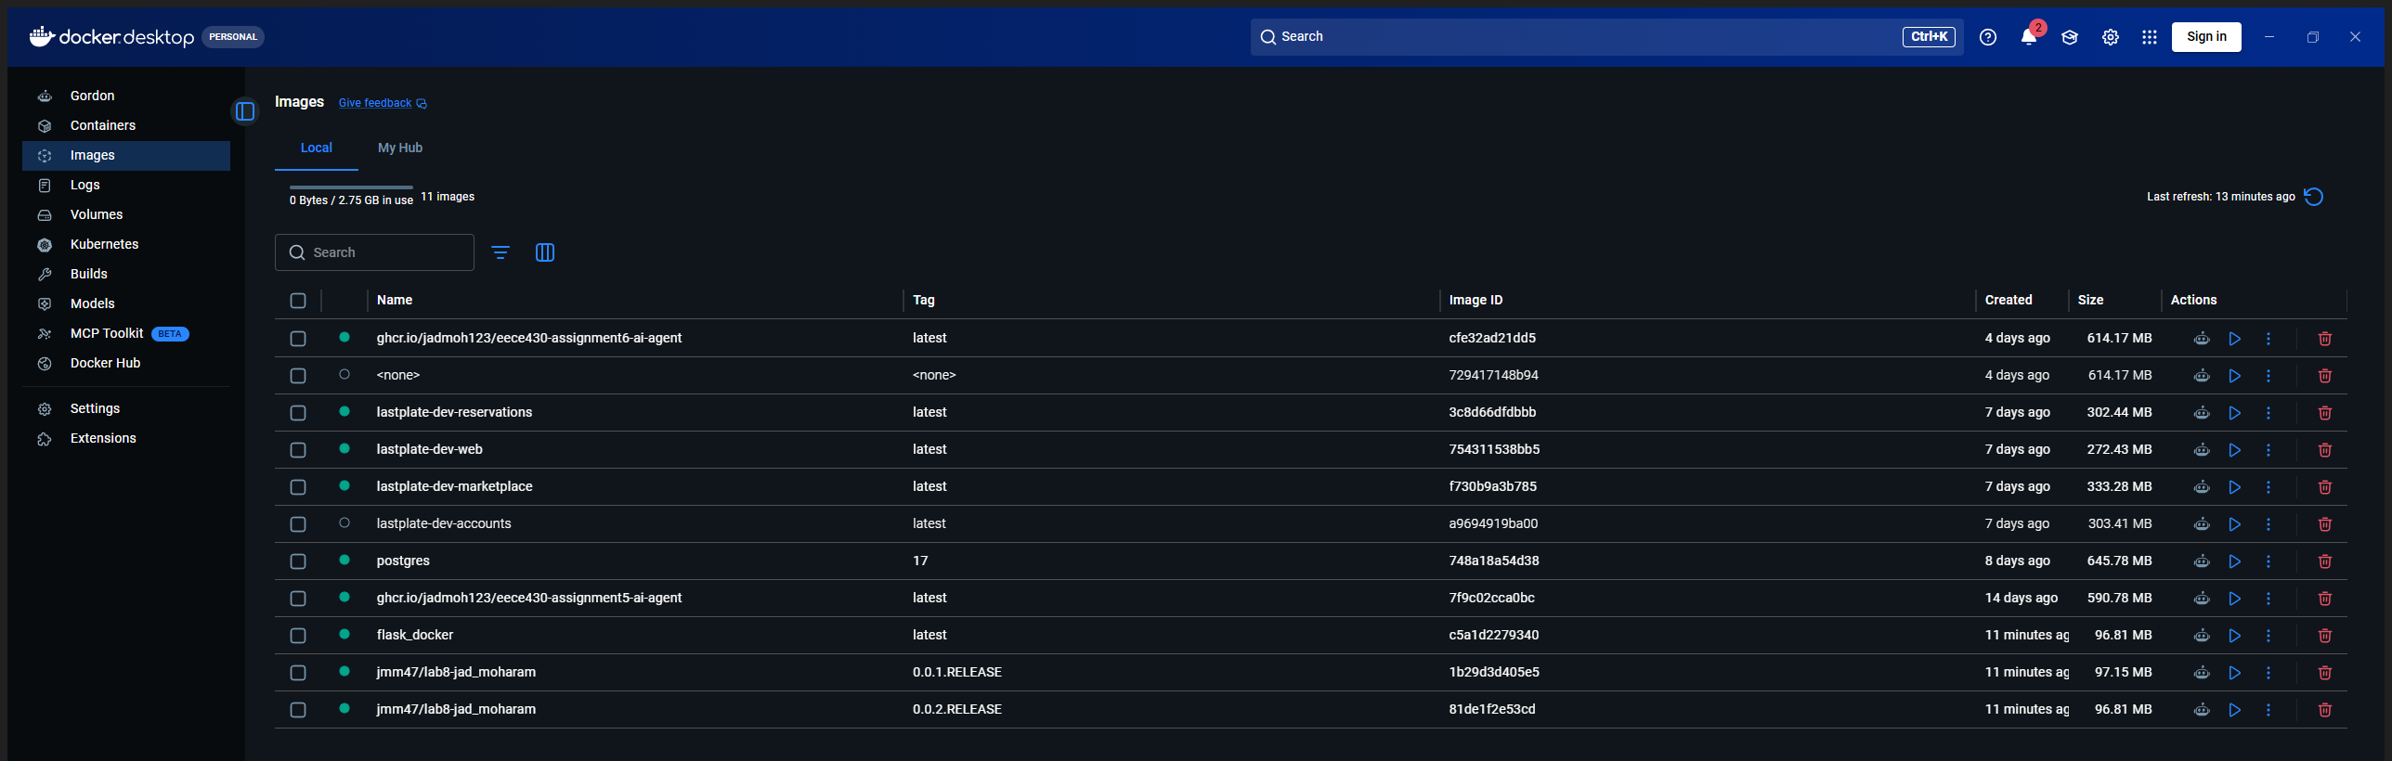
Docker Desktop – Images: jmm47/lab8-jad_moharam 0.0.1.RELEASE and 0.0.2.RELEASE

Image 1 – Lab 5 Postman and APIs on port 5000 (0.0.1.RELEASE)
docker image build -t jmm47/lab8-jad_moharam:0.0.1.RELEASE "lab5 api"
docker run -p 5000:5000 -d --name lab5_api jmm47/lab8-jad_moharam:0.0.1.RELEASE
Runs the Lab 5 users API (GET /api/users, GET /api/users/<id>, POST /api/users/add, PUT /api/users/update, DELETE /api/users/delete/<id>). GET http://localhost:5000/api/users returned the users in the database.
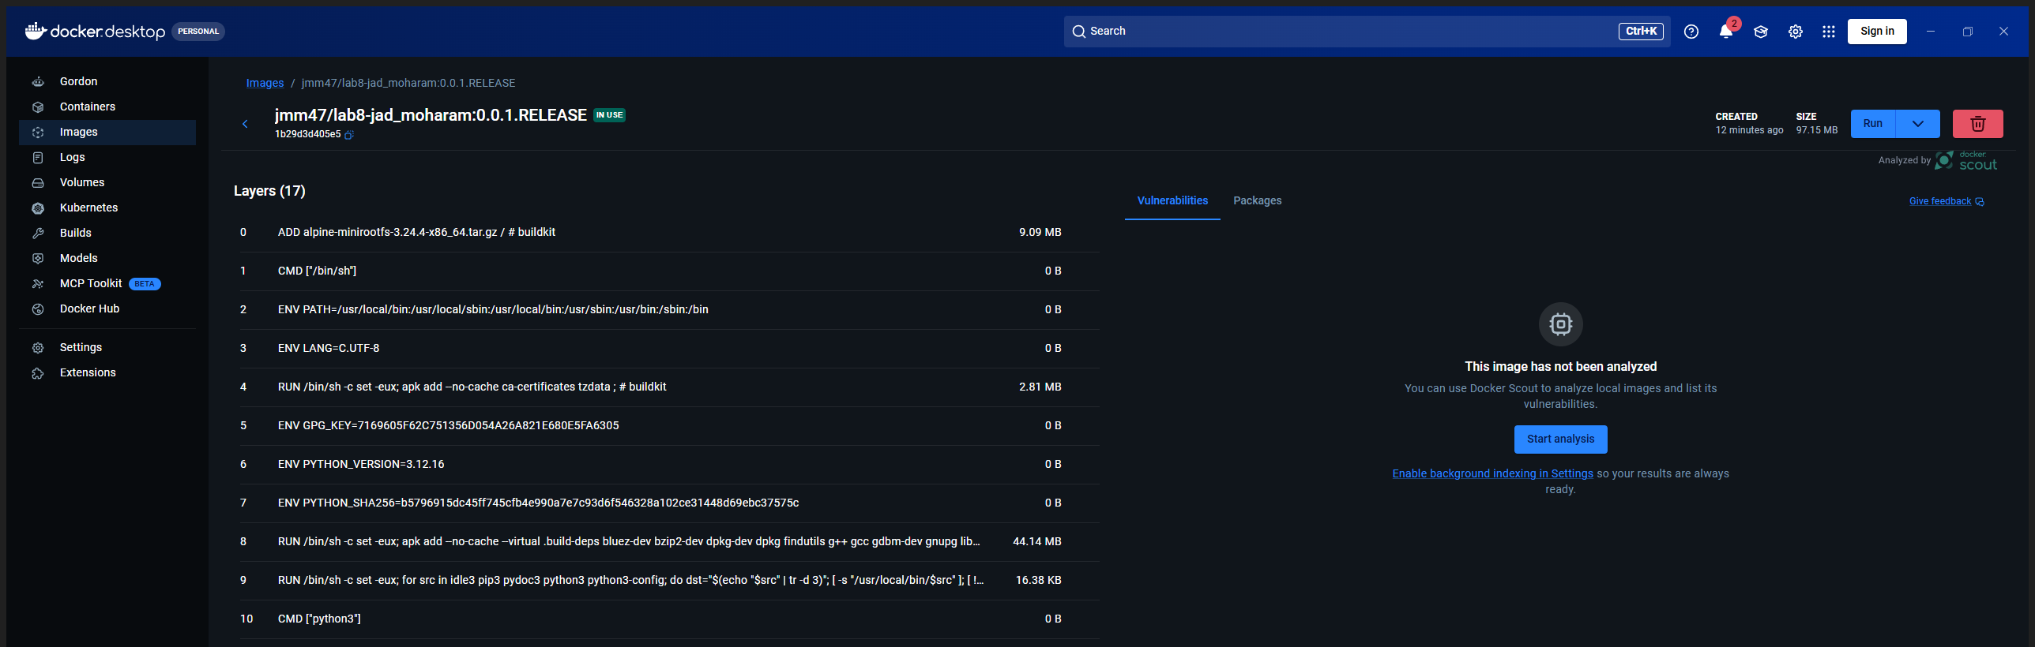
Docker Desktop – image jmm47/lab8-jad_moharam:0.0.1.RELEASE

Image 2 – get_users API on port 3000 (0.0.2.RELEASE)
docker image build -t jmm47/lab8-jad_moharam:0.0.2.RELEASE "get users api"
docker run -p 3000:3000 -d --name get_users_api jmm47/lab8-jad_moharam:0.0.2.RELEASE
Exposes GET /get_users, which returns the names of all the users in the database. GET http://localhost:3000/get_users returned:
["John Doe", "Jane Smith", "Ali Hassan"]
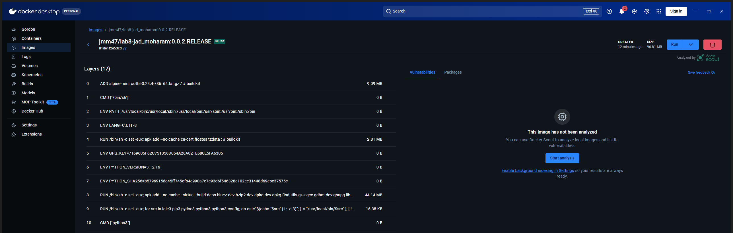
Docker Desktop – image jmm47/lab8-jad_moharam:0.0.2.RELEASE
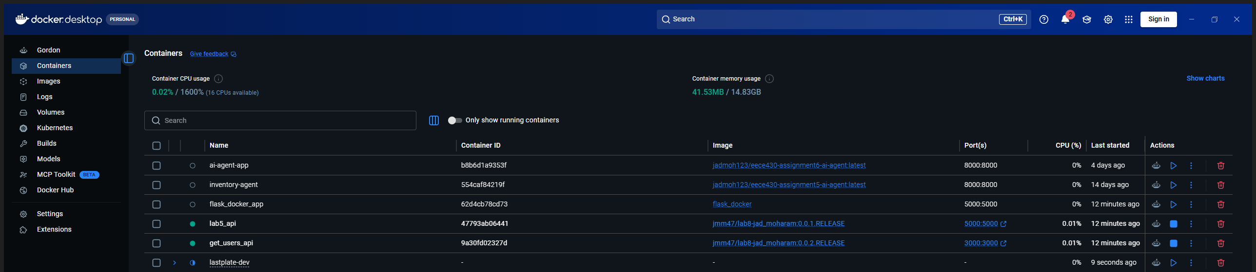
Docker Desktop – Containers: lab5_api on 5000:5000 and get_users_api on 3000:3000 running

